CENWP-OD 08 December 2016

MEMORANDUM FOR THE RECORD

Subject: DRAFT minutes for the 08 December 2016 FPOM meeting.

The meeting was held at the CRITFC Office in Portland, OR. In attendance:

|  |  |  |  |
| --- | --- | --- | --- |
| **Last** | **First** | **Agency** | **Email** |
| Bailey | John | NWW | [John.C.Bailey@usace.army.mil](mailto:John.C.Bailey@usace.army.mil) |
| Baus | Doug | NWD-RCC | [Douglas.m.baus@usace.army.mil](mailto:Douglas.m.baus@usace.army.mil) |
| Bettin | Scott | BPA | [swbettin@bpa.gov](mailto:swbettin@bpa.gov) |
| Conder | Trevor | NOAA | [trevor.conder@noaa.gov](mailto:trevor.conder@noaa.gov) |
| Cordie | Robert | NWP-TDA | [Robert.P.Cordie@usace.army.mil](mailto:Robert.P.Cordie@usace.army.mil) |
| Fredricks | Gary | NOAA | [Gary.Fredricks@noaa.gov](mailto:Gary.Fredricks@noaa.gov) |
| Hevlin | Bill | NOAA | Bill.Hevlin@noaa.gov |
| Iverson | Tom | Yakama |  |
| Johnson | Bobby | NWP | [Bobby.johnson@usace.army.mil](mailto:Bobby.johnson@usace.army.mil) |
| Kovalchuk | Erin | NWP | Erin.H.Kovalchuk@usace.army.mil |
| Lorz | Tom | CRITFC | [lort@critfc.org](mailto:lort@critfc.org) |
| Mackey | Tammy | NWP | [Tammy.m.mackey@usace.army.mil](mailto:Tammy.m.mackey@usace.army.mil) |
| McDonald | Joyce | NWW | [Joyce.M.McDonald@usace.army.mil](mailto:Joyce.M.McDonald@usace.army.mil) |
| Morrill | Charlie | WDFW | [Charles.Morrill@dfw.wa.gov](mailto:Charles.Morrill@dfw.wa.gov) |
| Peery | Chris | NWW | [Christopher.A.Peery@usace.army.mil](mailto:Christopher.A.Peery@usace.army.mil) |
| Royer | Ida | NWP | [Ida.M.Royer@usace.army.mil](mailto:Ida.M.Royer@usace.army.mil) |
| Setter | Ann | NWW | [Ann.l.setter@usace.army.mil](mailto:Ann.l.setter@usace.army.mil) |
| Swank | David | USFWS | [David_Swank@fws.gov](mailto:David_Swank@fws.gov) |
| Trachtenbarg | David | NWW | [David.a.Trachtenbarg@usace.army.mil](mailto:David.a.Trachtenbarg@usace.army.mil) |
| Walker | Ricardo | NWP | [Ricardo.Walker@usace.army.mil](mailto:Ricardo.Walker@usace.army.mil) |
| Wertheimer | Robert | NWP | [Robert.H.Wertheimer@usace.army.mil](mailto:Robert.H.Wertheimer@usace.army.mil) |
| Wright | Lisa | NWD-RCC | [Lisa.S.Wright@usace.army.mil](mailto:Lisa.S.Wright@usace.army.mil) |
| Zyndol | Miro | NWP | [Miro.A.Zyndol@usace.army.mil](mailto:Miro.A.Zyndol@usace.army.mil) |

On the phone: Bailey, Baus, Bettin, Conder, Cordie, Fredricks, Iverson, Johnson, Kovalchuk, McDonald, Morrill, Royer, Trachtenbarg, Walker, Wetheimer, Wright and Zyndol.

1. Decisions made at this meeting
   1. November meeting minutes approved
   2. BON EAL Testing update (16BON10) – ***FPOM concurred***
   3. Coordination Forms
      1. LWG MOC – ***FPOM concurred with this action and requests that diffuser 14 be returned to service as soon as the diver is out of the water.***
      2. 16BON120 MOC CI crowder repair – ***FPOM concurred with this action noting that earlier in the day is better.***
      3. 16JDA07 Dual Ladder Outage – ***FPOM concurred with this action. If the dual outage occurs, video monitoring will be required for post evaluation.***
   4. FPP Change forms
      1. 17MCN001 Updated spill patterns with no TSWs – ***Approved***
2. The following documents were provided or discussed. Documents may be found at http://www.nwd-wc.usace.army.mil/tmt/documents/FPOM/2010/
   1. *Agenda, Fish Passage O&M Coordination Team.*
   2. *NWW FPOM outages schedule*
   3. *Cooling Water Strainers Lamprey Count*
   4. *BON pinniped abundance 2016*
   5. *Coordination/Notification Forms (NWW/NWP)*
   6. *FPP change forms. (NWW/NWP)*
3. **Action Items**
   1. **NWW**
      1. [Dec 16] MCN- Johnson will send out a memo on the condition of the grating of the Washington Shore fish ladder to FPOM members.
      2. [Dec 16] **16 MCN 018 MFR Side dewatering brush -** Johnson will send out more pictures of the side brush
   2. **NWP**
      1. [Nov 16] **BON split flows** Action: Fredricks will send out his draft FPP change form to Mackey and Kovalchuk for review. *Status:* **Pending.** Fredricks still needs to look at the data first and will work with Lorz to create a proposal. The split flows may improve adult passage but it is not necessarily an improvement for juveniles plus there may be SLEDs installation to consider.
      2. [Nov16] **BON SLEDS (Fredricks)** ACTION: Fredricks will create his draft FPP change form and members will comment before sending to Wright. *Status*: **Pending.** There are several options: leave all SLEDs in all the time, pull them for June and July or leaving in for certain entrances and not others. FFU provided a handout on sealion abundance in the tailrace at BON for 2016 (posted on the website). Increasing velocities with SLEDs might not be good for lamprey. Royer said that a major issue is having to move the crane from one side of the project to the other. The crane can’t pass over the spillway so it needs to be driven via the highway to the other side. It may not be practical to drop/pull SLEDs based on conditions. Peery said that there was no major delay with spring chinook but there is no data on sockeye or lamprey so June could be an issue. Leaving the SLEDs in all the time would therefore be a gamble. Another option is to pull them on the side that the crane is on for the month of June. Conder had reservations about pulling the SLEDS and taking the risk that a sealion might get into the ladder without the data of delay to sockeye/lamprey. Once a sealion is in the ladder, there is no easy way of getting it out. FFU data shows that there are always sealions in the tailrace. **ACTION:** A separate meeting will be scheduled for this topic.
      3. [Dec 16] BON SLEDs – A separate meeting will be scheduled for this topic.
   3. **Completed Action Items or to be discussed later in the agenda**
      1. [Nov 16] MOCs fish impact analysisAction: Fredricks will draft an FPP change form with the minimum criteria for the fish impact section. *Status: Completed*
      2. [NOV 16]BON WA SH early outage work schedule (16BON116) Action: Royer will send a priority work list.
      3. [Nov 16] BON T11 / T12(16BON14) Action: Baus will send out a new teletype without the corner collector running during the two week outage. *Status: Completed*
      4. [Nov 16] JDA STS condition Action: Zyndol will create an MFR to send out to the region so everyone is aware of the current situation. *Status: Completed*
      5. [Oct 16] 15TDA08 transformer/installation (Walker). Action: Walker will update the MOC with the new dates. ***Status: The schedule is still changing so no MOC. Walker will update when the schedule is solidified****.*
      6. [Oct16] Fish Counts and Web Posting (FFU). ACTION: Wertheimer will put together a press release about the situation.***Status: Not completed and now it is too late. FPC did a memo for the public.***
      7. [Oct 16] FCRPS temperature monitoring. If there is evidence that Bonneville, The Dalles and John Day forebays do not stratify then the USGS data would be acceptable. ACTION: Lundell will provide the FFU data to FPOM.***Status: information posted to http://www.nwd-wc.usace.army.mil/tmt/documents/FPOM/2010/2016_FPOM_MEET/2016_OCT/***
      8. [Oct 16] Winter Maintenance Schedule. ACTION: BON has posted their winter maintenance schedule but TDA and JDA need to send their schedules to Kovalchuk and Mackey for posting. ***Status: schedules posted to http://www.nwd-wc.usace.army.mil/tmt/documents/FPOM/2010/Plans%20lists%20charts/***
4. **Updates**
   1. **NWW**
      1. Upcoming maintenance/construction/research activities. [FPOMOUTAGES]
         1. LWG – Unit 1 schedule to return at the end of March. Hevlin had concerns about extending into May but the work continues on schedule. DWK unit 3 is scheduled to return on July1 which is 32 days behind schedule. The crews are working double shifts to get the work completed.
         2. Long term path MCN fish pumps (McDonald) – There is a need for spare parts for important equipment like the fish pumps. Some parts require long lead times for fabrication. Fredricks suggested adding a spare part requirement in the new Bi Op to minimize downtime. The project recognizes that the units are old and are formulating a plan for the future rather than concentrating on spare parts. McDonald, Asset Manager for Environmental Stewardship for Walla Walla District, called in to explain what the process will be for the fish pump program. Currently, the project is in phase 1A of a large capital project where all alternative are on the table. The project manager will review the alternatives report and send out the proposed alternatives for a concurrent review to the regional agencies in July or August. FY18 budget will include money to engineer a design on the chosen alternative. Construction will most likely be in FY 19, 20 and 21. The completion date is scheduled for June 2022.
         3. MCN – The Washington shore ladder is due for a dive inspection of the grating but it is not feasible this year. The project will pump the water down low enough to visibly look at the grating. ACTION: Johnson will send out a memo on the condition of the grating to FPOM members. Dropping the water level is better than a camera but not as good as a diver. At the next maintenance meeting, the project will discuss what to do in the event of a dislodged grating. Most likely, if the grating needs work, it would require a contract and not just fixed in house.
         4. MCN juvenile warm weather temperature collection handout updated (posted on website)
   2. **NWP**
      1. Upcoming maintenance/construction/research activities.
         1. FGE Mods. - On schedule.
         2. BON PIT TAG room – No update.
         3. BON T11 / T12(16BON14) – Completed and can be removed from the agenda.
         4. BON LFS repairs. (16BON11) – All scheduled work was completed. The project tried to piggy back on the T11/12 outage but still required some additional spill. Other LPS work is on-going.
         5. BON B-Branch erosion (16BON107) – The coordination form didn’t explain how the biological concerns of this work were addressed. The MOC will be updated with the DDR and the charter with the biological considerations to the repair. The work is starting at the end of December.
         6. BON WA SH Dewatering and work schedule (16BON116) - Dewatered on the 28th of November to tailwater. The fish exit channel from the serpentine section upstream was dewatered and only minor debris was found. The UMT and south monolith were dewatered the following day. The whole PH2 collection channel could not be dewatered because there are not enough solid bulkhead. On December 5th, the north monolith was dewatered. A sealion went into the north monolith before the dewatering but left on his own accord. The AWS was dewatered and no problems found. V69 has been removed and being repaired. The north C valve was inspected; the valves 1-4 are still under water. Two of the B diffusers which are located along the south monolith will be repaired this year and the other diffuser will be repaired in two years.
         7. BON EAL testing (16BON10) Royer – The updated MOC includes the current dates and adds additional monitoring testing. The testing will require 2-3 hours of outages for 5 different days but no dewatering is required. All outages are scheduled for 2017. FPOM concurred with this action.
         8. TDA AWS Construction (16TDA10) – The newly discovered beams had to be jackhammered which took about two nights and one day as coordinated. Personnel watched the count station window. The jackhammering was louder than expected but no abnormal behavior was observed. Dive operations started the first week of December - mostly surveying. The drilling on the face of the dam starts mid- December. Cordie will continue to include pictures in the weekly report.
         9. TDA fish unit rehab – Phase 1A is to evaluate the entire system by 2018 to determine the three major risks - reliability, environmental concerns, and operational challenges. The project is slated for completion by April 2022. The project would like to achieve more flow per unit and have the ability to run one unit with all entrances in criteria. This will be updated once a year.
      2. BON FOG Bulkheads – Mackey reported that Ian Chane was told that the FOG bulkheads can’t be covered by CRFM as previously stated but this issue is being looked into at SCT.
      3. JDA STS crane failure – The crane has been out of service since late October. It is in very poor condition and has been on the district funding list for 10 years. An emergency contract has been awarded and the crane is expected to return to service in early January. Zyndol stressed that this is just a band aid and not a long term fix. There is a failed screen in unit 3 so the unit has been OOS since Nov 10. The screens will not be removed on Dec 15 but the camera inspection will continue. This outage will affect the winter maintenance schedule. The JBS will remain in service. Once the crane is working, the screens will be removed and visually inspected.
      4. JDA STS condition – The MFR was completed. If the overhaul is not completed soon, the screens may have to be replaced since the mechanical parts could be corroding. Mackey said the project needs to include the overhaul of one set of screens in the budget each year and get them done incrementally.
      5. JDA South fishway AWS pump 1 funding – The funding has been pending at the District level for years. A charter is being created so that the PDT can be established. The pump needs to be completely rehabbed.
      6. JDA north pumps lubrication – Mechanics are addressing the issue. There are enough pumps to keep the ladder in criteria if one trips. Zyndol will update the status of this equipment in the weekly reports.
      7. Winter dewatering activities
         1. BON Washington shore dewatering – Discussed above.
         2. TDA dewatering of east ladder – Blockers at the south entrance moved and allowed three steelhead to strand themselves on the grating. The structural crew is addressing this situation.
         3. JDA JBS and north fish ladder dewatering – No issues.
   3. **Research/FFDRWG updates –** There will be a lamprey RT study from U of Idaho. They will mount a Didson near the ramps of the LPS and two half duplex near the count station of the Washington Shore ladder. There may be inference problems with the full duplex.Use this link to find out more about the research programs:[**www.nwd-wc.usace.army.mil/tmt/documents/FPOM/2010/NWP%20Research/Research.html**](http://www.nwd-wc.usace.army.mil/tmt/documents/FPOM/2010/NWP%20Research/Research.html)
   4. **RCC update**

|  |  |  |  |  |
| --- | --- | --- | --- | --- |
| **Project** | **Previous day average (kcfs)** | **5 day forecast average (kcfs)** | **10 day forecast average (kcfs)** | **Projected Low/Peak (kcfs) and date.** |
| **LWG** | 18 | 19 | 21 | 19 (12/13) /  21 (12/17) |
| **MCN** | 154 | 134 | 139 | 133 (12/14) /  149 (12/8) |
| **BON** | 164 | 145 | 148 | 143 (12/15) /  163 (12/8) |

**Table 1. RCC flow forecast**

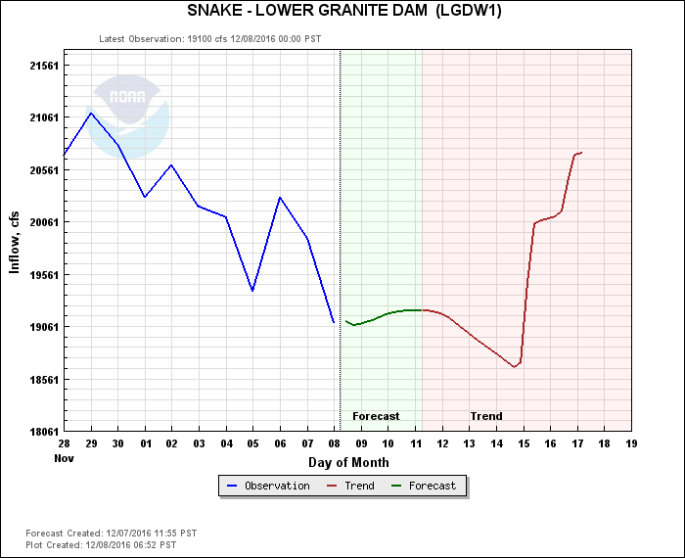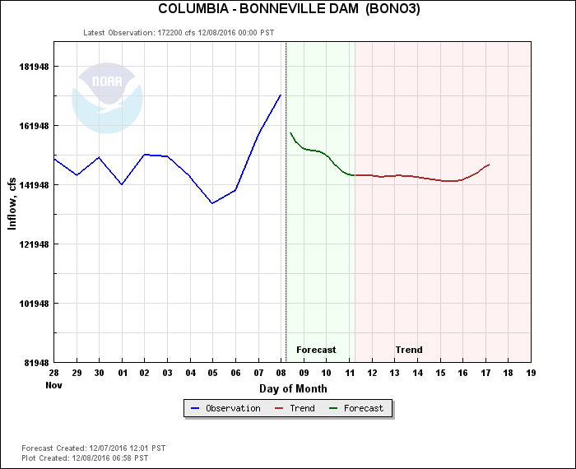

* 1. **BPA update –** No changes.
  2. **Pinniped update – (Handout posted to the website)** Wertheimer noted that there are higher number of Stellers this year, especially immature ones. Currently, there are between 20- 50 hanging around in the tailrace. Lorz asked if NOAA has given permission to brand Stellers next year but the answer is unknown.
  3. **Lamprey update –** All preliminary results from this year were presented at AFEP. The report is being finalized.
     1. **134 PIT detection –** The long range plan is to install full duplex antennas at all the exits and half duplex at the LPS. PSMFC continues to maintain the PIT systems for monitoring. The LPS returns to service on April 1. The PIT and RT study will start after the Bradford Island structure is in place. Study plans to come.
  4. **Avian update**
     1. **TDA (Cordie) -** Waiting on an estimate for wires from USDA.
     2. **JDA (Zyndol) -** On schedule to have the 15 lines reinstalled.
     3. **MCN –** Several issues need to be resolved about pelicans like if hazing needs to stop because pelicans are nearby and can pelicans be directly hazed. Morrill is looking into it. After the pelican is down listed, then a decision can be made.
  5. **Fish Counts** – Fish counts are no longer being published to the website. The old server was moved and now the link cannot be reestablished. Either the PAO will manually publish the data or the data will be redirected to FPC or DART websites. Wertheimer is working on a press release for the public. Wertheimer can provide counts to anyone who needs them via email while they are trying to get the situation fixed.

1. **PH1 new trash rack design (Royer) –** Anengineer is in the beginning phase of designing a new trashrack and wants to incorporate any fish concerns. Cleaning is the foremost issues for the fish managers. Any comments should be sent to Royer.
2. **Coordination/Notification forms (need concurrence/discussion)**
   1. **16 MCN 018 MFR Side dewatering brush –** For the month of November, the side brush has been problematic. All above water fixes had been completed but the brush continued to stop cycling. After dewatering the area, it was discovered that the guide rails had misaligned. The orifices had to be closed to fully dewater the system. ACTION: Johnson will send out more pictures of the side brush. The system is in emergency by-pass mode. The system would have been switched on Dec 16th for fish screen removal. All 42 orifices are now open. Fredricks had no issues with this work.
   2. **16 IHR 011 MFR** South shore AWS pumps temporarily turned off – No comments.
   3. **LWG MOC** (Trachtenbarg) – The work had been coordinated as night work but it now needs to be during the day. The ladder will be out of criteria for the length of the dive but will stay watered up. Work will start on Tuesday, December 13, first thing in the morning and possibly on Wednesday as well and the dive takes place between the ladder and unit 1 (already out of service). FPOM concurred with this action and requests that diffuser 14 be returned to service as soon as the diver is out of the water.
   4. **16BON119 MOC CI crowder installation –** The coordinated operations had too much water to complete the work so the project was forced to close the UMT for three days. The water level stayed at orifice flow but no fish could pass. No additional comments.
   5. **16BON120 MOC CI crowder repair –** A piece of wood is lodged under the crowder. The crowder can’t move and the window can’t be cleaned. The project will have to remove the crowder and it is expected to take three hours. FPOM concurred with this action noting that earlier in the day is better.
   6. **16JDA07** Dual Ladder Outage – This outage is to support the PIT antenna installation. The contract was awarded a week late. After the initial meeting with the contractor, they feel that the work will be completed on time but Walker said that the MOC outage would be a contingency plan. The project did not want to go into March and preferred the dual ladder outage. FPOM concurred with this action but requested video counts if the dual outage occurs. Once the ladder reopens, look to see if there is a large response. FFU could take video and the infrastructure is in place already.
3. **Fish Passage Plan:** The Current 2016 FPP and Draft 2017 FPP Change Forms are online at: [http://www.nwd-wc.usace.army.mil/tmt/documents/fpp/](http://www.nwd-wc.usace.army.mil/tmt/documents/fpp/2014/changes/index.html).
   1. Pending FPP Change Forms.
      1. **17OVE001 – MOC Fish Impacts Section (Fredricks) – Pending;** Setter requested more time.
      2. **17BON003 – Nighttime Lamprey Operations**. **Withdrawn.** Tackley requested via email the form be withdrawn until further investigation is made.
      3. **17BON005 – Oil Spill Response.** (Hausmann). Pending from November.
      4. **17MCN001 Updated spill patterns with no TSWs.** (Setter). Discussed at Nov FPOM and FFDRWG. **Approved.**
      5. **17LWG001 – Forebay Exit Cooling Pumps.** (Setter). Revised and emailed May 16. STATUS: Will revisit at the beginning of 2017.
   2. New FPP Change Forms
      1. **17AppA001 – Doble Testing Schedule.** (Setter)
4. **Task Group Updates.**
   1. BON minimum spill to maintain good B2CC egress. (Fredricks and Lorz). Team: Bettin, Ebner, Hausmann, Mackey, Rerecich, Wright. Date for test selected?
   2. Hazmat response. (Cordie). Team: Baus, Bettin, Conder, Fredricks, Hausmann, Lorz, Mackey, Wright, Zyndol. Next meeting after January FPOM. Coast Guard and EPA do not have COE on NW Area Plan Consultation. Conder will send contact info to Mackey and Setter for coordination.